# Optional: Upload the movie dataset to BigQuery

The next video demonstrates how to use SQL to filter data in a large dataset in BigQuery.

If you would like to follow along with the instructor, you will need to log in to your BigQuery account and upload the movie dataset provided as a CSV file. If you haven't set up a BigQuery account, refer to [Using BigQuery](https://www.coursera.org/learn/data-preparation/supplement/DYOQK/using-bigquery).

Download the CSV file:

[Movie Data.csv](https://d3c33hcgiwev3.cloudfront.net/KNFbyUKxRKiRW8lCsQSo8A_8adeac50825b4df68daaf6055c404ef1_Movie-Data.csv?Expires=1623196800&Signature=FESUI0NKnvBXvnhtBRLCZEg-qfc1rYjqhY66SaSD~aMhs09XWFMn52TDSxRi~yXX7Lr6xe7EO9YtFlfFNBcrLaiWljoSzzaOYqJZY1g34tYWdzBOx3eUZxyZ3~xHRpogja2OJdS23vPACe19z~eA2igfoBaVW66tsm8A9zzU3Kg_&Key-Pair-Id=APKAJLTNE6QMUY6HBC5A)

After you download the CSV file, follow Steps 3 through 16 in the [step-by-step instructions for uploading a CSV file to BigQuery](https://scribehow.com/shared/Uploading-a-CSV-file-to__3qDWEO9rS6iORNQN_rBFSw).

For these particular steps in the instructions, be sure to note and do the following instead:

* Step 5: Instead of clicking CREATE DATASET, click the Actions icon (three vertical dots) next to your project and select Create dataset.

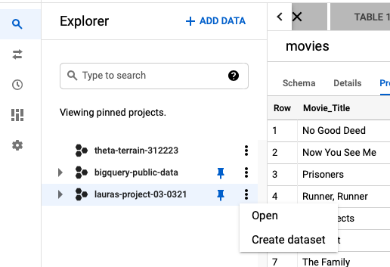

* Step 6: Under Create dataset, for Dataset ID enter movie_data to match the dataset in the video.
* Step 14: Under Destination, for Table name enter movies to match the table in the video.

Finally, to be ready to follow along with the instructor, complete these steps after you upload the CSV file:

1. In the Explorer pane of your BigQuery console, expand your project and navigate to movie_data and then click the movies table.
2. Click the Preview tab to confirm that you can see the movie data. You should see data similar to the following:

